Safety evaluation of ethanolic Morus alba leaf extract as a potential therapeutic agent for metabolic syndrome: a 28-day subacute toxicity study in rats

ABSTRACT
Introduction: Morus alba leaf extract has pharmacological potential for metabolic disorders, but repeated-dose safety data for ethanolic preparations remain limited. Methods: This study evaluated the 28-day oral toxicity of ethanolic M. alba leaf extract (EEM) in adult Wistar rats. Thirty rats of both sexes were randomly divided into a normal control group and two treatment groups receiving EEM at 200 or 400 mg/kg body weight for 28 consecutive days. Body weight was recorded weekly. Hematological indices, serum creatinine, urea, aspartate aminotransferase, alanine aminotransferase, and liver and kidney histopathology were assessed at the end of treatment. Results: No mortality or overt clinical signs of toxicity were observed. Body weight generally increased in all groups. Most hematological and biochemical parameters were comparable between treated and control rats, although selected erythrocyte-related indices and creatinine differed in female rats. Liver histology showed mild hydropic or cellular degeneration at 200 mg/kg and moderate hepatic alterations, including fatty degeneration, necrosis, and inflammatory cell infiltration, at 400 mg/kg. Kidney tissue remained normal at 200 mg/kg, whereas mild renal edema was observed at 400 mg/kg. Conclusion: EEM was generally tolerated in repeated oral administration, but dose-related liver and kidney histological changes at 400 mg/kg indicate that further safety evaluation and dose-ranging studies are required before therapeutic development.
Keywords: Morus alba; subacute toxicity; ethanolic extract; Wistar rats; histopathology; metabolic syndrome

INTRODUCTION
Metabolic syndrome (MetS) is characterized by central obesity, insulin resistance, dyslipidemia and impaired glucose regulation, and it increases the risk of cardiovascular disease and type 2 diabetes mellitus.^{1,2} Poor long-term adherence to pharmacological and lifestyle interventions remains a major challenge in chronic metabolic disorders, encouraging continued exploration of complementary agents with multiple metabolic targets and acceptable safety profiles.³
Medicinal plants contain diverse bioactive compounds that may act on key mechanisms involved in MetS, including insulin signaling, lipid and glucose metabolism, oxidative stress and low-grade inflammation.⁴⁻⁶ Morus alba L. has long been used in Asian traditional medicine and has been reported to contain flavonoids, alkaloids, phenolic acids and related constituents with hypoglycemic, antioxidant, anti-inflammatory, anti-obesity, cardiometabolic and pancreatic beta-cell protective properties.⁷⁻¹³ These pharmacological findings support further development of M. alba leaf preparations as potential complementary candidates for metabolic disorders.
Before such preparations can be advanced for therapeutic use, their repeated-dose safety must be established. Existing toxicity data are encouraging but remain incomplete. Acute studies of M. alba preparations have reported no mortality or major toxic signs at high single doses, and a 28-day study of an aqueous extract showed no relevant toxicity at doses up to 4000 mg/kg/day.¹⁴⁻¹⁷ However, these findings cannot be directly generalized to ethanolic extracts because extraction solvent can substantially influence the phytochemical composition, extraction yield and biological activity of plant preparations.^{18,19}
Repeated-dose oral toxicity studies over 28 days are commonly used to identify target-organ toxicity and provide preliminary safety information for compounds intended for prolonged exposure.²⁰ Hematological indices, serum biochemical markers and histopathological examination are particularly relevant for plant-derived preparations because the liver and kidneys are central to xenobiotic metabolism and elimination. Therefore, this study aimed to evaluate the 28-day oral toxicity of ethanolic M. alba leaf extract in male and female Wistar rats by assessing body weight, hematological profiles, liver and kidney function markers, and liver and kidney histopathology.

MATERIALS AND METHODS

Plant material and extraction
Morus alba leaves were collected from Wajo Regency, South Sulawesi, Indonesia. The dried powdered leaves were extracted by maceration with 70% ethanol according to a previously described natural-product extraction approach.²¹ The powdered material was moistened and soaked in solvent, then kept in a dark place at room temperature for 72 hours with occasional stirring. After filtration, the remaining residue was remacerated using the same solvent. The combined filtrates were concentrated using a rotary evaporator at 60 °C and 75 rpm to obtain a thick extract. The extract was frozen at -20 °C for approximately 24 hours and subsequently lyophilized for 24 hours to produce a dry extract. Freeze-drying was used to improve extract stability and maintain the integrity of bioactive constituents.²²

Animals and ethical approval
Thirty adult Wistar rats of both sexes (2-3 months old, 150-180 g) were used in this study. The animals were obtained from the Faculty of Pharmacy, Hasanuddin University, Indonesia. During a one-week acclimatization period, rats were maintained under standard laboratory conditions with a 12-hour light/dark cycle and free access to food and water. Only animals that maintained or gained body weight during acclimatization were included. This animal study was approved by the Research Ethics Committee of Sekolah Tinggi Ilmu Farmasi under approval number 12.199/KOMETIK/STIFA/XII/2025. The general care and handling of experimental animals were conducted in accordance with institutional guidelines and applicable animal welfare principles.

Subacute toxicity study
The subacute oral toxicity study was conducted for 28 consecutive days. After weighing, animals were randomly allocated into three groups, each comprising 10 rats (5 males and 5 females). Group I served as the normal control group, whereas groups II and III received ethanolic M. alba leaf extract (EEM) at doses of 200 and 400 mg/kg body weight, respectively. The extract was administered orally once daily for 28 days. Animals were observed for mortality and overt clinical signs of toxicity during the treatment period. Body weight was recorded weekly. At the end of treatment, blood samples were collected via orbital venous sinus and cardiac puncture for hematological and biochemical analyses. The animals were then euthanized, and liver and kidney tissues were collected for histopathological examination.

Hematological analysis
Hematological parameters included erythrocyte count, red blood cell indices, total and differential white blood cell counts, and platelet indices. Measurements were performed in the Clinical Pharmacy Laboratory, Faculty of Pharmacy, Hasanuddin University, using an automated hematology analyzer (Dymind DH36, Dymind Biotechnology, Shenzhen, China).

Biochemical analysis
Serum biochemical indices included creatinine and urea for kidney function and aspartate aminotransferase (AST) and alanine aminotransferase (ALT) for liver function. Measurements were performed in the Clinical Pharmacy Laboratory, Faculty of Pharmacy, Hasanuddin University, using a Humalyzer 4000 analyzer (HUMAN Diagnostics, Wiesbaden, Germany) with HUMAN diagnostic kits.

Histopathological analysis
Liver and kidney tissues were fixed in formalin and processed according to standard histological procedures. Briefly, tissues were dehydrated through graded alcohol solutions, embedded in paraffin, sectioned into 5 µm-thick slices, stained with hematoxylin and eosin (H&E), and examined under a light microscope for histopathological alterations.

Statistical analysis
Body weight, hematological and biochemical data were expressed as mean +/- standard deviation. Differences among groups were analyzed using one-way analysis of variance followed by the least significant difference post hoc test using SPSS version 24. Statistical significance was accepted at P < 0.05.

RESULTS

Body weight changes and clinical observation
No mortality or overt signs of toxicity were observed in either sex during the 28-day administration of EEM. All groups showed an overall increase in body weight over the treatment period (Figure 1). Among female rats, the normal control group showed a 23.5% increase, whereas the EEM 200 and 400 mg/kg groups gained 7.6% and 12.5%, respectively. Among male rats, the normal control and EEM 400 mg/kg groups showed comparable increases of approximately 38% and 30%, respectively, while the EEM 200 mg/kg group showed a more modest increase of approximately 10%.
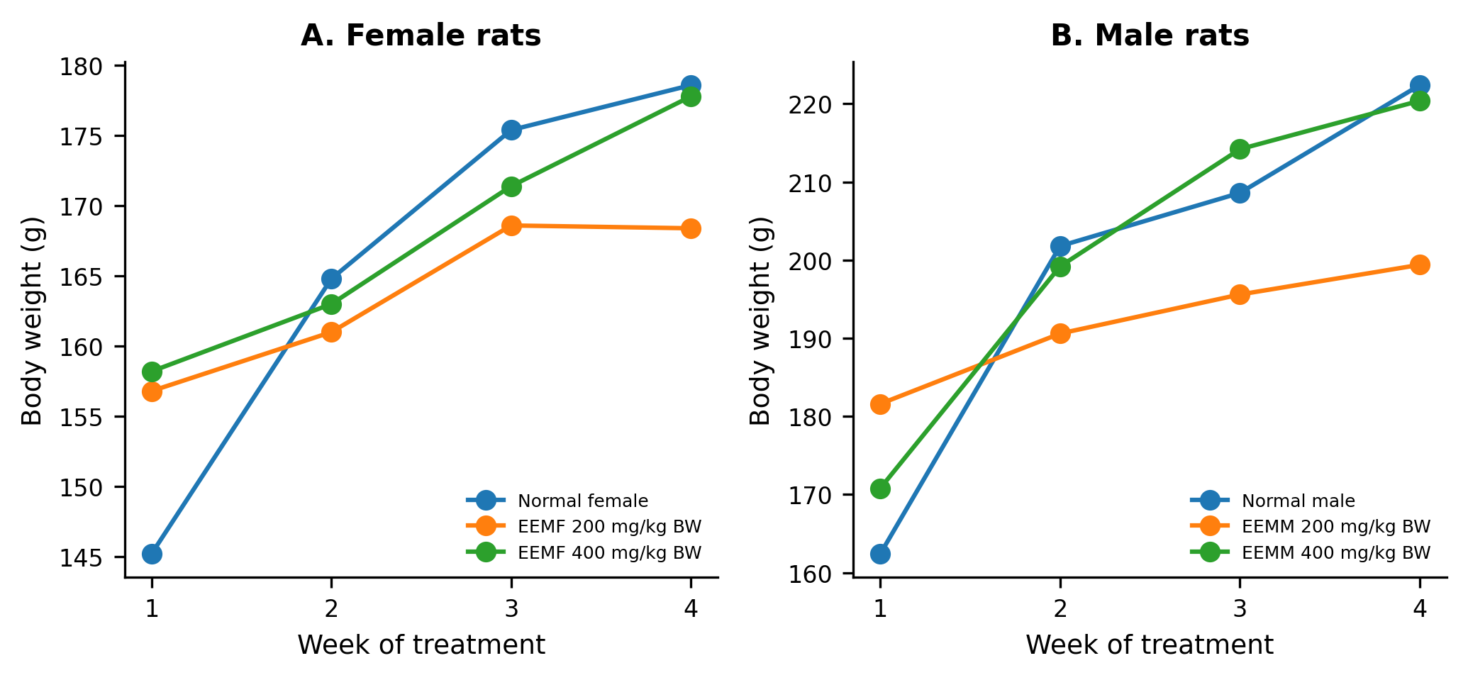
Figure 1. Average body weight of Wistar rats administered ethanolic extract of Morus alba leaves during the 28-day toxicity evaluation: (A) female rats and (B) male rats. EEMF, ethanolic extract of Morus alba leaves in female rats; EEMM, ethanolic extract of Morus alba leaves in male rats.

Hematological findings
Hematological analysis was performed to evaluate potential blood-related effects of EEM in male and female rats. In female rats, leukocyte and platelet parameters were generally comparable between treated groups, whereas selected erythrocyte-related indices differed significantly among groups (Table 1). In male rats, erythrocyte, leukocyte and platelet parameters were comparable across the control and EEM-treated groups (Table 2).
Table 1. Hematological parameters in female rats after 28 days of treatment.
Parameter | Normal control | EEM 200 mg/kg BW | EEM 400 mg/kg BW
Erythrocytes (10^6/µL) | 6.75 +/- 0.31 | 7.32 +/- 0.40 | 7.37 +/- 0.54
Hemoglobin (g/dL) | 16.32 +/- 0.90 (a) | 17.80 +/- 0.82 (b) | 17.06 +/- 0.61 (a,b)
Hematocrit (%) | 41.08 +/- 1.14 (a) | 44.58 +/- 1.93 (b) | 44.34 +/- 2.49 (b)
MCV (fL) | 60.88 +/- 1.54 | 60.92 +/- 1.42 | 60.20 +/- 2.17
MCH (pg) | 24.18 +/- 0.49 | 24.32 +/- 1.45 | 23.24 +/- 1.28
MCHC (g/dL) | 39.72 +/- 1.39 | 39.94 +/- 1.87 | 38.52 +/- 1.03
RDW-CV (%) | 17.08 +/- 1.31 | 15.00 +/- 1.27 | 15.82 +/- 1.04
RDW-SD (fL) | 35.06 +/- 2.60 (a) | 30.80 +/- 2.14 (b) | 31.94 +/- 2.35 (a,b)
Mentzer index | 9.04 +/- 0.62 | 8.35 +/- 0.62 | 8.21 +/- 0.83
RDWI | 154.51 +/- 14.58 (a) | 125.17 +/- 11.76 (b) | 130.21 +/- 16.51 (b)
WBC (10^3/µL) | 21.52 +/- 3.17 (a) | 14.54 +/- 2.15 (b) | 15.13 +/- 5.90 (b)
Lym (%) | 94.76 +/- 1.67 | 93.96 +/- 4.25 | 92.88 +/- 2.54
Gran (%) | 1.14 +/- 0.42 | 1.56 +/- 1.28 | 1.72 +/- 0.80
Mid (%) | 4.10 +/- 1.40 | 4.48 +/- 2.97 | 5.40 +/- 1.75
Lym (10^9/L) | 20.38 +/- 2.85 | 13.63 +/- 1.95 | 14.02 +/- 5.32
Gran (10^9/L) | 0.25 +/- 0.10 | 0.24 +/- 0.21 | 0.27 +/- 0.19
Mid (10^9/L) | 0.90 +/- 0.37 | 0.67 +/- 0.48 | 0.84 +/- 0.47
PLT (10^3/µL) | 1260.20 +/- 245.70 | 1123.60 +/- 112.93 | 1065.60 +/- 99.80
MPV (fL) | 7.32 +/- 0.33 | 7.58 +/- 0.52 | 7.34 +/- 0.39
PDW (%) | 7.84 +/- 0.39 | 7.66 +/- 0.97 | 8.10 +/- 0.45
PCT (%) | 0.93 +/- 0.20 | 0.85 +/- 0.12 | 0.78 +/- 0.08
P-LCR (%) | 12.32 +/- 2.58 | 15.02 +/- 3.78 | 11.92 +/- 2.44
P-LCC (10^3/µL) | 158.20 +/- 50.92 | 170.40 +/- 51.50 | 126.80 +/- 30.43
Data are expressed as mean +/- SD (n = 5 per group). Different superscript letters indicate significant differences between groups (P < 0.05); identical letters indicate no significant difference. EEM, ethanolic extract of Morus alba leaves.
Table 2. Hematological parameters in male rats after 28 days of treatment.
Parameter | Normal control | EEM 200 mg/kg BW | EEM 400 mg/kg BW
Erythrocytes (10^6/µL) | 7.80 +/- 1.17 | 7.81 +/- 0.84 | 8.41 +/- 0.54
Hemoglobin (g/dL) | 17.34 +/- 2.42 | 17.90 +/- 1.70 | 18.98 +/- 0.61
Hematocrit (%) | 45.62 +/- 7.29 | 45.80 +/- 4.03 | 49.94 +/- 2.49
MCV (fL) | 58.48 +/- 1.15 | 58.78 +/- 2.03 | 59.40 +/- 2.17
MCH (pg) | 22.30 +/- 0.39 | 23.00 +/- 0.98 | 22.62 +/- 1.28
MCHC (g/dL) | 38.14 +/- 1.22 | 39.12 +/- 0.65 | 38.10 +/- 1.03
RDW-CV (%) | 17.68 +/- 1.37 | 18.42 +/- 1.31 | 17.14 +/- 1.04
RDW-SD (fL) | 34.58 +/- 2.30 | 36.22 +/- 2.34 | 33.96 +/- 2.35
Mentzer index | 7.65 +/- 1.25 | 7.62 +/- 1.16 | 7.12 +/- 0.83
RDWI | 134.69 +/- 18.81 | 139.49 +/- 16.09 | 121.88 +/- 16.51
WBC (10^3/µL) | 15.53 +/- 4.35 | 18.64 +/- 5.12 | 14.94 +/- 5.90
Lym (%) | 93.96 +/- 3.11 | 89.82 +/- 11.47 | 94.34 +/- 2.54
Gran (%) | 1.44 +/- 0.94 | 3.34 +/- 4.65 | 1.58 +/- 0.80
Mid (%) | 4.60 +/- 2.19 | 6.84 +/- 6.86 | 4.08 +/- 1.75
Lym (10^9/L) | 14.53 +/- 3.91 | 16.33 +/- 2.78 | 14.12 +/- 5.32
Gran (10^9/L) | 0.24 +/- 0.18 | 0.78 +/- 1.25 | 0.23 +/- 0.19
Mid (10^9/L) | 0.75 +/- 0.46 | 1.52 +/- 1.88 | 0.59 +/- 0.47
PLT (10^3/µL) | 847.20 +/- 257.22 | 1030.00 +/- 102.41 | 968.00 +/- 99.80
MPV (fL) | 7.00 +/- 0.23 | 6.98 +/- 0.31 | 7.10 +/- 0.39
PDW (%) | 7.94 +/- 0.44 | 7.44 +/- 0.92 | 7.92 +/- 0.45
PCT (%) | 0.59 +/- 0.18 | 0.72 +/- 0.10 | 0.69 +/- 0.08
P-LCR (%) | 9.44 +/- 1.44 | 10.90 +/- 1.81 | 10.70 +/- 2.44
P-LCC (10^3/µL) | 79.40 +/- 28.07 | 113.20 +/- 28.27 | 103.20 +/- 30.43
Data are expressed as mean +/- SD (n = 5 per group). EEM, ethanolic extract of Morus alba leaves.

Serum biochemical findings
Repeated oral administration of EEM for 28 days did not significantly change urea, AST or ALT levels compared with the normal control groups in either sex (Tables 3 and 4). Creatinine levels in male rats were comparable across groups. In female rats, creatinine differed significantly between the normal control and EEM 200 mg/kg groups and between the EEM 200 and 400 mg/kg groups.
Table 3. Serum biochemical parameters in female rats after 28 days of treatment.
Parameter | Normal control | EEM 200 mg/kg BW | EEM 400 mg/kg BW
Creatinine (mg/dL) | 1.70 +/- 0.26 (a) | 1.15 +/- 0.18 (b) | 1.58 +/- 0.11 (a)
Urea (mg/dL) | 33.58 +/- 3.18 | 47.63 +/- 8.70 | 39.24 +/- 12.71
AST (U/L) | 225.80 +/- 76.42 | 199.20 +/- 38.17 | 217.75 +/- 7.72
ALT (U/L) | 61.00 +/- 13.71 | 47.00 +/- 8.34 | 68.20 +/- 15.94
Data are expressed as mean +/- SD (n = 5 per group). Different superscript letters indicate significant differences between groups (P < 0.05); identical letters indicate no significant difference. AST, aspartate aminotransferase; ALT, alanine aminotransferase; EEM, ethanolic extract of Morus alba leaves.
Table 4. Serum biochemical parameters in male rats after 28 days of treatment.
Parameter | Normal control | EEM 200 mg/kg BW | EEM 400 mg/kg BW
Creatinine (mg/dL) | 1.39 +/- 0.45 | 1.40 +/- 0.15 | 1.32 +/- 0.13
Urea (mg/dL) | 40.06 +/- 4.88 | 40.06 +/- 11.37 | 44.40 +/- 11.66
AST (U/L) | 205.20 +/- 9.63 | 264.20 +/- 39.44 | 215.60 +/- 7.72
ALT (U/L) | 65.00 +/- 15.41 | 67.00 +/- 14.95 | 62.80 +/- 15.94
Data are expressed as mean +/- SD (n = 5 per group). AST, aspartate aminotransferase; ALT, alanine aminotransferase; EEM, ethanolic extract of Morus alba leaves.

Histopathological findings
Microscopic examination of liver sections showed mild hydropic or cellular degeneration in male and female rats treated with EEM at 200 mg/kg body weight (Figures 2 and 3). At 400 mg/kg body weight, more pronounced hepatic alterations were observed in both sexes, including moderate fatty degeneration, hepatocellular necrosis and inflammatory cell infiltration. Kidney histology was normal in both sexes at 200 mg/kg, with preserved glomerular and tubular structures. Mild renal edema was observed at 400 mg/kg in both sexes (Figure 4).
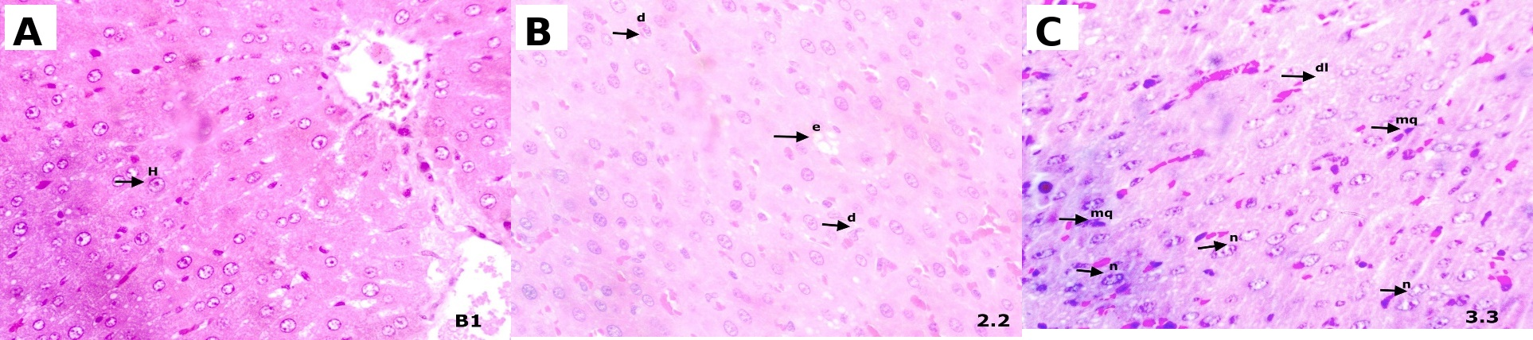
Figure 2. Liver histology of female rats after 28 days of treatment with ethanolic Morus alba leaf extract (H&E, 40x). (A) Control group showing preserved hepatic architecture. (B) EEM 200 mg/kg showing mild edema and cellular degeneration. (C) EEM 400 mg/kg showing moderate hepatic alterations, including necrosis, macrophage infiltration and fatty degeneration. EEM, ethanolic extract of Morus alba leaves.
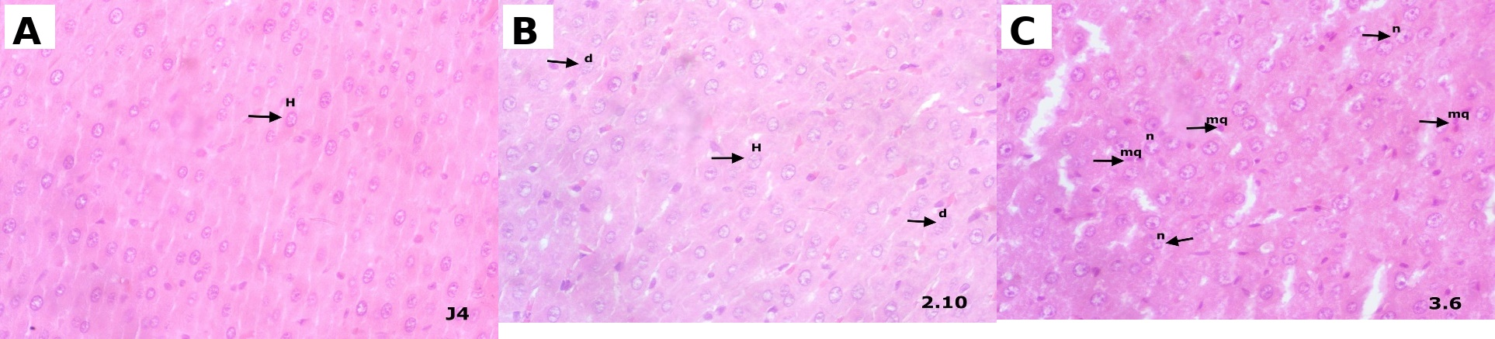
Figure 3. Liver histology of male rats after 28 days of treatment with ethanolic Morus alba leaf extract (H&E, 40x). (A) Control group showing preserved hepatic architecture. (B) EEM 200 mg/kg showing mild cellular degeneration. (C) EEM 400 mg/kg showing moderate hepatic alterations, including necrosis and macrophage infiltration. EEM, ethanolic extract of Morus alba leaves.
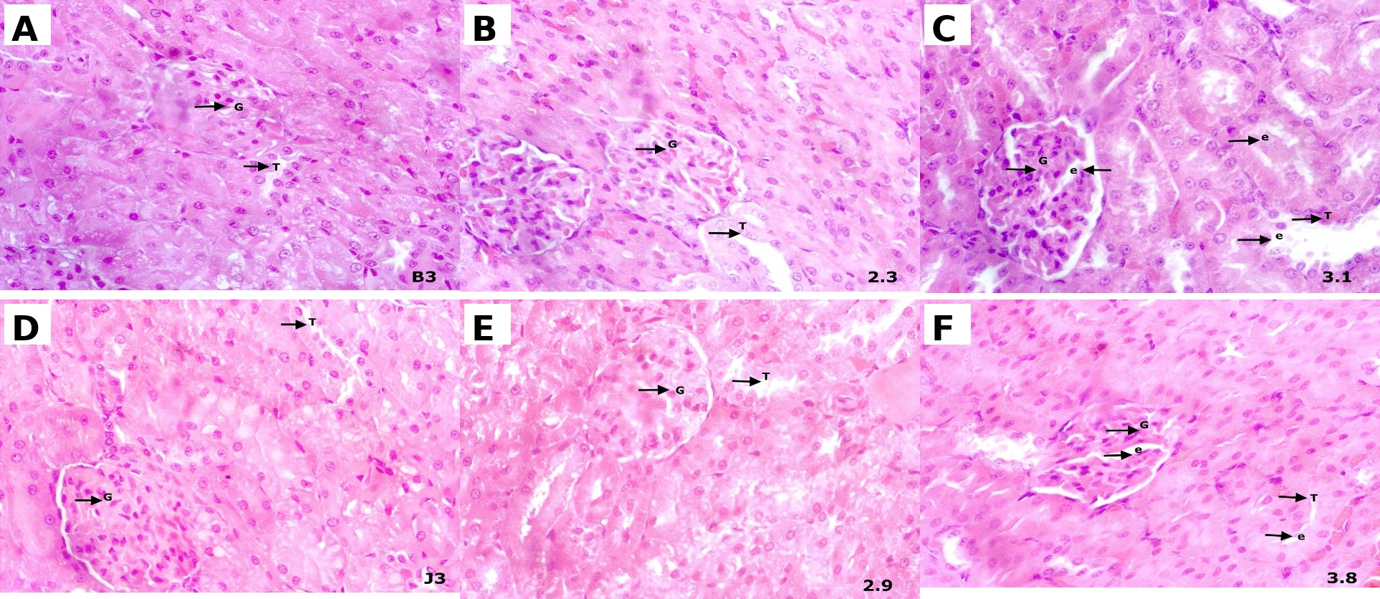
Figure 4. Kidney histology of female and male rats after 28 days of treatment with ethanolic Morus alba leaf extract (H&E, 40x). (A-C) Female rats: control, EEM 200 mg/kg and EEM 400 mg/kg. (D-F) Male rats: control, EEM 200 mg/kg and EEM 400 mg/kg. Kidney structure remained preserved at 200 mg/kg, whereas mild edema was observed at 400 mg/kg. EEM, ethanolic extract of Morus alba leaves.

DISCUSSION
This study evaluated the 28-day repeated oral toxicity of ethanolic M. alba leaf extract in male and female Wistar rats. No mortality or overt clinical toxicity was observed during treatment, and all groups showed progressive body-weight gain. Body weight is a sensitive indicator in repeated-dose toxicity studies because marked weight loss or growth suppression may indicate systemic toxicity, metabolic stress or reduced food intake.²³⁻²⁵ Although the magnitude of body-weight gain varied between groups and sexes, the absence of weight loss supports the general tolerability of EEM under the tested conditions.
The present findings are broadly consistent with previous safety reports on M. alba preparations. Acute toxicity assessment of M. alba leaf extract reported no major toxic signs after high-dose exposure, and repeated administration of an aqueous extract produced no treatment-related toxicity at markedly higher doses than those used in the present study.^{14,16} However, the current study extends available information by focusing on an ethanolic leaf extract, which may have a different phytochemical profile from aqueous preparations because extraction solvent influences compound yield and biological activity.^{18,19}
Hematological assessment provides an important indication of possible systemic toxicity because blood cells and hematopoietic tissues can be sensitive to toxicant exposure.²⁶ In male rats, erythrocyte, leukocyte and platelet parameters were comparable across groups. In female rats, several erythrocyte-related indices differed statistically among groups, but the overall pattern did not indicate overt hematological toxicity. Variability in rat hematological parameters can be influenced by age, sex, strain, housing conditions and supplier origin.²⁷⁻²⁹ Therefore, statistically significant changes should be interpreted together with dose-response pattern, related parameters and histological evidence.
Serum creatinine and urea were used to assess kidney function, whereas AST and ALT were used as markers of hepatocellular injury. Creatinine and urea are widely used indicators of renal function and nitrogen metabolism, although each may be influenced by physiological factors other than kidney injury.³⁰⁻³² In the present study, urea did not differ significantly between control and treated groups, and male creatinine levels were comparable across groups. Female creatinine showed a significant difference involving the 200 mg/kg group, but this pattern was not dose-dependent. Previous experimental studies have reported protective or neutral effects of M. alba preparations on renal biomarkers in different models.³³⁻³⁵
AST and ALT levels did not significantly differ between control and EEM-treated groups in either sex. These enzymes are widely used in liver function assessment, although AST is less liver-specific than ALT because it is also present in cardiac and skeletal muscle, kidney and other tissues.³⁶ The lack of significant aminotransferase elevation suggests that EEM did not produce measurable biochemical liver injury during the 28-day period. Nevertheless, normal serum enzymes do not exclude early or mild tissue-level injury.
Histopathological findings provided the most important safety signal in this study. At 200 mg/kg, liver sections showed mild hydropic or cellular degeneration, while kidney tissues remained normal. At 400 mg/kg, moderate hepatic changes, including fatty degeneration, necrosis and inflammatory cell infiltration, and mild renal edema were observed. The liver is highly vulnerable to repeated exposure to xenobiotics because it is the primary site of metabolic activation and detoxification.³⁷ Herbal-induced liver injury may involve direct hepatocellular toxicity, reactive metabolite formation, oxidative stress, mitochondrial dysfunction and immune-mediated mechanisms.^{38,39} These mechanisms could plausibly explain the discrepancy between unchanged serum transaminases and microscopic liver alterations.
The mild renal edema observed at 400 mg/kg may reflect early renal stress. The kidneys are vulnerable to xenobiotic-induced injury because renal tubular cells are exposed to filtered compounds and metabolites during elimination.⁴⁰ Some phytochemical classes, including triterpenoid-rich extracts and flavonoids under pro-oxidant conditions, have been associated with renal or oxidative tissue stress despite their pharmacological benefits.⁴¹⁻⁴³ Thus, the renal histology findings should be interpreted cautiously and warrant confirmatory studies with additional renal biomarkers, organ-weight analysis and longer observation periods.
This study has several limitations. First, the sample size per sex and group was limited, which reduces statistical power and the ability to detect subtle toxicological effects. Second, organ weights, food and water intake, phytochemical standardization and quantitative histopathological scoring were not reported. Third, only two dose levels were evaluated, so a definitive no-observed-adverse-effect level could not be established. Despite these limitations, the combination of hematological, biochemical and histopathological endpoints provides useful preliminary evidence for the repeated-dose safety profile of ethanolic M. alba leaf extract.

CONCLUSION
Ethanolic Morus alba leaf extract was generally tolerated after 28 days of repeated oral administration in male and female Wistar rats, with no mortality, overt clinical toxicity, or consistent biochemical evidence of liver or kidney dysfunction. However, the histopathological alterations observed in liver and kidney tissues, particularly at 400 mg/kg body weight, indicate potential dose-related target-organ effects. Further safety studies using broader dose ranges, longer exposure periods, phytochemical standardization, organ-weight assessment and quantitative histopathological scoring are needed before this extract is advanced as a therapeutic candidate for metabolic syndrome.

ETHICAL ISSUES
This animal study was approved by the Research Ethics Committee of Sekolah Tinggi Ilmu Farmasi under approval number 12.199/KOMETIK/STIFA/XII/2025. Animal care and experimental procedures were conducted with consideration of ethical issues and in accordance with institutional guidelines and applicable animal welfare principles. Informed consent was not applicable because this study did not involve human participants or identifiable human data.

CONFLICT OF INTERESTS
The authors declare no conflict of interests.

FUNDING/SUPPORT
This study received financial support from the Ministry of Higher Education, Science, and Technology through Fundamental Grant funding. The authors also received institutional support from Universitas Almarisah Madani.

ACKNOWLEDGEMENTS
The authors express their sincere appreciation to the Ministry of Higher Education, Science, and Technology for the financial support provided through the Fundamental Grant funding. The authors also thank Universitas Almarisah Madani for institutional support and the research team and colleagues for their collaboration and valuable input during the study.

AUTHORS' CONTRIBUTIONS
MS, SSM, IM, AA, AR, PAD, APL, ANS, IY and DR contributed to the conception, study implementation, data acquisition, analysis, drafting or critical revision of the manuscript. All authors reviewed and approved the final version of the manuscript for submission.

DATA AVAILABILITY
The data supporting the findings of this study are available from the corresponding author upon reasonable request.

REFERENCES
- Obeidat AA, Ahmad MN, Ghabashi MA, Alazzeh AY, Habib SM, Abu Al-Haijaa D, et al. Developmental trends of metabolic syndrome in the past two decades: a narrative review. J Clin Med. 2025;14(7). doi:10.3390/jcm14072402.
- Muvhulawa N, Dludla PV, Ndlovu M, Ntamo Y, Mayeye A, Luphondo N, et al. Global trends in clinical trials and interventions for the metabolic syndrome: a comprehensive analysis of the WHO International Clinical Trials platform. Contemp Clin Trials Commun. 2024;40:101330. doi:10.1016/j.conctc.2024.101330.
- Religioni U, Barrios-Rodríguez R, Requena P, Borowska M, Ostrowski J. Enhancing therapy adherence: impact on clinical outcomes, healthcare costs, and patient quality of life. Medicina (Kaunas). 2025;61(1). doi:10.3390/medicina61010153.
- Li M, Ding L, Cao L, Zhang Z, Li X, Li Z, et al. Natural products targeting AMPK signaling pathway therapy, diabetes mellitus and its complications. Front Pharmacol. 2025;16:1534634. doi:10.3389/fphar.2025.1534634.
- Altanam SY, Darwish N, Bakillah A. Exploring the interplay of antioxidants, inflammation, and oxidative stress: mechanisms, therapeutic potential, and clinical implications. Diseases. 2025;13(9). doi:10.3390/diseases13090309.
- Manful CF, Fordjour E, Ikumoinein E, Abbey L, Thomas R. Therapeutic strategies targeting oxidative stress and inflammation: a narrative review. BioChem. 2025;5(4). doi:10.3390/biochem5040035.
- Batiha GE, Al-Snafi AE, Thuwaini MM, Teibo JO, Shaheen HM, Akomolafe AP, et al. Morus alba: a comprehensive phytochemical and pharmacological review. Naunyn Schmiedebergs Arch Pharmacol. 2023;396(7):1399-1413. doi:10.1007/s00210-023-02434-4.
- Chen S, Xi M, Gao F, Li M, Dong T, Geng Z, et al. Evaluation of mulberry leaves' hypoglycemic properties and hypoglycemic mechanisms. Front Pharmacol. 2023;14:1045309. doi:10.3389/fphar.2023.1045309.
- Suthamwong P, Minami M, Okada T, Shiwaku N, Uesugi M, Yokode M, et al. Administration of mulberry leaves maintains pancreatic beta-cell mass in obese/type 2 diabetes mellitus mouse model. BMC Complement Med Ther. 2020;20(1):136. doi:10.1186/s12906-020-02933-4.
- Trimarco V, Gallo P, Ghazihosseini S, Izzo A, Rozza PI, Spinelli A, et al. White mulberry plant extracts in cardiovascular prevention: an update. Nutrients. 2025;17(14). doi:10.3390/nu17142262.
- Salampe M, Rahimah S, Nur S, Mamada SS, Biring FS, Keyzia K, et al. Uji aktivitas antioksidan ekstrak daun murbei (Morus alba) menggunakan metode BCB, CUPRAC, dan FRAP. Jurnal Mandala Pharmacon Indonesia. 2025;11(1):149-157. doi:10.35311/jmpi.v11i1.723.
- Salampe M, Widiasri DAD, Wahyuddin N, Agus RR, Imrawati I, Awaluddin A, et al. Therapeutic effects of Morus alba leaf extract on fasting blood glucose and pancreatic beta-cell restoration in HFD-STZ-induced diabetic rats. Jurnal Jamu Indonesia. 2026;11(2):111-118. doi:10.29244/jji.v11i2.452.
- Porasar P, Gibo R, Gogoi B, Sharma D, Bharadwaj A, Gam S, et al. A systematic review on the phytochemistry, isolated compounds, nutritional benefits, pharmacology and toxicology of the plant species Morus alba L. Discover Plants. 2025;2(1):7. doi:10.1007/s44372-024-00043-w.
- Fauzi A, Kifli N, Noor MHM, Hamzah H, Azlan A. Hematological, biochemical, and histopathological evaluation of the Morus alba L. leaf extract from Brunei Darussalam: acute toxicity study in ICR mice. Open Vet J. 2024;14(3):750-758. doi:10.5455/OVJ.2024.v14.i3.1.
- Li Y, Zhang X, Liang C, Hu J, Yu Z. Safety evaluation of mulberry leaf extract: acute, subacute toxicity and genotoxicity studies. Regul Toxicol Pharmacol. 2018;95:220-226. doi:10.1016/j.yrtph.2018.03.007.
- Nurita R, Vitriana A, Sukmara IM, Utami N. Mulberry leaves (Morus alba) for diabetes mellitus: acute toxicity test in male Wistar rats. Journal of Vocational Health Studies. 2018;1(1).
- Marx TK, Glávits R, Endres JR, Palmer PA, Clewell AE, Murbach TS, et al. A 28-day repeated dose toxicological study of an aqueous extract of Morus alba L. Int J Toxicol. 2016;35(6):683-691. doi:10.1177/1091581816670597.
- Bouasla I, Hamel T, Barour C, Bouasla A, Hachouf M, Bouguerra OM, et al. Evaluation of solvent influence on phytochemical content and antioxidant activities of two Algerian endemic taxa. Eur J Integr Med. 2021;42:101267. doi:10.1016/j.eujim.2020.101267.
- Sun S, Yu Y, Jo Y, Han JH, Xue Y, Cho M, et al. Impact of extraction techniques on phytochemical composition and bioactivity of natural product mixtures. Front Pharmacol. 2025;16:1615338. doi:10.3389/fphar.2025.1615338.
- OECD. Test Guideline No. 407: repeated dose 28-day oral toxicity study in rodents. OECD Guidelines for the Testing of Chemicals. 2025;407.
- Zhang QW, Lin LG, Ye WC. Techniques for extraction and isolation of natural products: a comprehensive review. Chin Med. 2018;13:20. doi:10.1186/s13020-018-0177-x.
- Coşkun N, Sarıtaş S, Jaouhari Y, Bordiga M, Karav S. The impact of freeze drying on bioactivity and physical properties of food products. Applied Sciences. 2024;14(20). doi:10.3390/app14209183.
- Chapman K, Sewell F, Allais L, Delongeas JL, Donald E, Festag M, et al. An evidence-based approach to define the upper limit of body weight loss in short term toxicity studies. Regul Toxicol Pharmacol. 2013;67(1):27-38. doi:10.1016/j.yrtph.2013.04.003.
- Marxfeld HA, Küttler K, Dammann M, Gröters S, van Ravenzwaay B. Body and organ weight data in 28-day toxicological studies in two mouse strains. Data Brief. 2019;27:104632. doi:10.1016/j.dib.2019.104632.
- Taylor-Lapole AM, Cunny HC, Shockley KR. Statistical analysis of rodent body weight data is robust to departures from normality in historical National Toxicology Program studies dated 1980-2013. J Young Investig. 2022;25(7):1-12. doi:10.22186/jyi.25.5.1.1.
- Arika W, Nyamai DW, Musila MN, Ngugi MP, Njagi ENM. Hematological markers of in vivo toxicity. J Hematol Thromboembolic Dis. 2016;4(2):1000236. doi:10.4172/2329-8790.1000236.
- Sood P, Shri R, Singh V, Ahmad SF, Attia SM. Acute oral toxicity and safety assessment of Morus alba L. methanol fruit extract in mice. Int J Food Sci. 2024;36(3):11-19. doi:10.15586/ijfs.v36i3.2578.
- Rahmawati N, Syukri M, Darmawi D, Zachreini I, Zulfiani U, Yusuf M, et al. Haematological features of white rats infected with S. pyogenes and administered with probiotics. ScientificWorldJournal. 2022;2022:2899462. doi:10.1155/2022/2899462.
- Kampfmann I, Bauer N, Johannes S, Moritz A. Differences in hematologic variables in rats of the same strain but different origin. Vet Clin Pathol. 2012;41(2):228-234. doi:10.1111/j.1939-165X.2012.00427.x.
- Filho WJ, Lima CC, Rodolfo M, Paunksnis R, Silva AA, Perilhão MS, et al. Reference database of hematological parameters for growing and aging rats. Aging Male. 2018;21(2):145-148. doi:10.1080/13685538.2017.1350156.
- Ávila M, Mora Sánchez MG, Bernal Amador AS, Paniagua R. The metabolism of creatinine and its usefulness to evaluate kidney function and body composition in clinical practice. Biomolecules. 2025;15(1). doi:10.3390/biom15010041.
- Gowda S, Desai PB, Kulkarni SS, Hull VV, Math AAK, Vernekar SN. Markers of renal function tests. North Am J Med Sci. 2010;2(4):170-173.
- Inker LA, Titan S. Measurement and estimation of GFR for use in clinical practice: core curriculum 2021. Am J Kidney Dis. 2021;78(5):736-749. doi:10.1053/j.ajkd.2021.04.016.
- Dkhil MA, Bauomy AA, Diab MSM, Al-Quraishy S. The antioxidant effect of Morus alba leaves extract on kidney, testes, spleen and intestine of mice. Pak J Zool. 2015;47(2):393-397.
- Fauzi A, Titisari N, Noor MHM, Azlan A, Hamzah H. Therapeutic effect of Morus alba leaf extract and chlorogenic acid on inhibiting the progression of kidney disease. Cogent Food Agric. 2024;10(1):2301841. doi:10.1080/23311932.2024.2301841.
- Nguyen NK, Nguyen HTT, Mai TP, Trinh QV, Duong NT, Pham PX, et al. Protective effects of Morus alba Linn leaf extract on streptozotocin-induced diabetic nephropathy in mice model. Phytomedicine Plus. 2025;5(3):100819. doi:10.1016/j.phyplu.2025.100819.
- Altaihani RA, Fahad B, Alhazmi S, Albagawi MG, Mohamad N, Almuzaini A, et al. Liver function tests: an updated review article for clinical pathologists. J Pharm Bioallied Sci. 2024;23:1681-1691.
- Zhang Y, Qi Y, Huang S, Jiang X, Xiao W, Wang L, et al. Role of ER stress in xenobiotic-induced liver diseases and hepatotoxicity. Oxid Med Cell Longev. 2022;2022:4640161. doi:10.1155/2022/4640161.
- Łupina K, Nowak A, Jabłońska A, Potaczek A, Salacha J, Ilkiewicz Ł, et al. Herb-induced liver injury. Livers. 2025;5(4). doi:10.3390/livers5040055.
- Liu C, Fan H, Li Y, Xiao X. Research advances on hepatotoxicity of herbal medicines in China. Biomed Res Int. 2016;2016:7150391. doi:10.1155/2016/7150391.
- George B, You D, Joy MS, Aleksunes LM. Xenobiotic transporters and kidney injury. Adv Drug Deliv Rev. 2017;116:73-91. doi:10.1016/j.addr.2017.01.005.
- Akpan JL, Wokota PN, Ohadoma SC, Onwudiwe TC, Okoroama CE, Iganga ON, et al. Evaluation of nephrotoxicity effects of the methanol leaf extract of A. angustifolia in Wistar rats. J Appl Sci Environ Manag. 2024;13(3):307-314.
- Adebiyi OA, Ameh DA, Onyike E, James DB. Hepatotoxic and nephrotoxic effect of ethanol leaf extract of Scoparia dulcis (Linn) in Wistar rats. J Pharm Res. 2021;2(4):20-27.
- Jomova K, Alomar SY, Valko R, Liska J, Nepovimova E, Kuca K, et al. Flavonoids and their role in oxidative stress, inflammation, and human diseases. Chem Biol Interact. 2025;413:111489. doi:10.1016/j.cbi.2025.111489.

